A Review of Visual Question Answer
YiYang A2_16
Introduction
Visual Question Answering (VQA) system is an algorithm that takes an image and a natural language question about it as input and produces an accurate answer as the output. VQA represents not a narrowly defined problem, but a rich range of semantic scene understanding problems and related research directions. Visual Q&A provides users with a more convenient and efficient way to analyze any given image in work, study, data analysis, research and life.
Principals of VQA
Using Convolutional Neural Network (CNN) for image recognition, using Recurrent Neural Network (RNN) for natural language processing, then combining the results to deliver the final answer [1]

Our Work
Several recent papers have begun to study visual question answering. However, our team has been mainly focused on the other side. Our aim is to use artificial intelligence to help blind and other visually impaired groups deal with some of the problems they encounter in daily life. We have implemented speech to text API so that blind people can ask vocal questions to the application and the app will automatically generate to text information.
We have set up the speech to text API environment and written codes to apply the function. And the function was operated successfully in both Jupyter Notebook and Python.
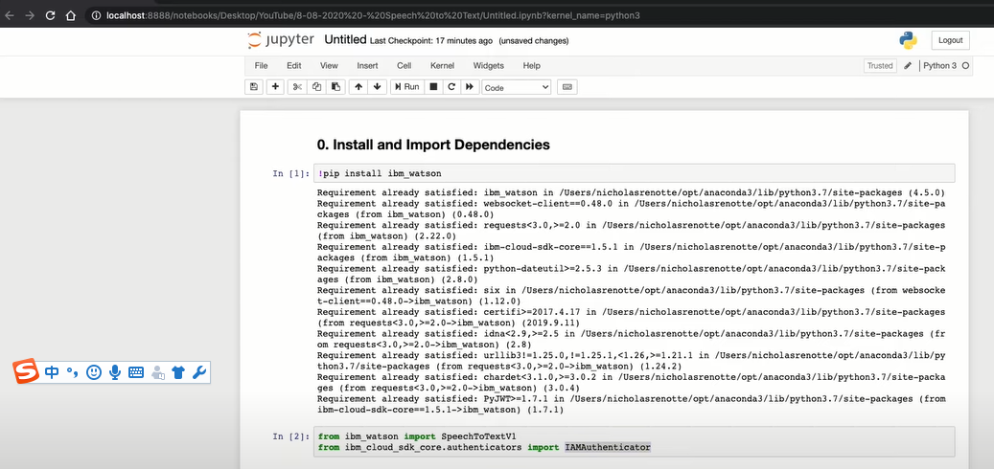
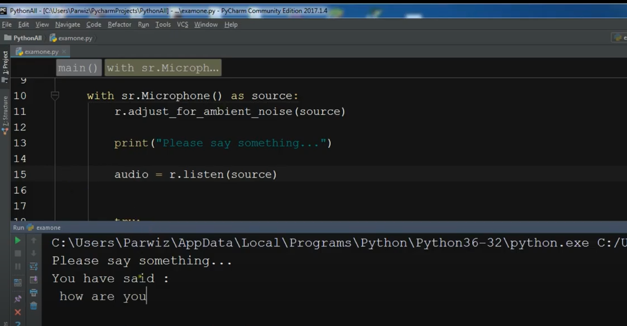
We also tested some audio sources and it gives out accurate results.
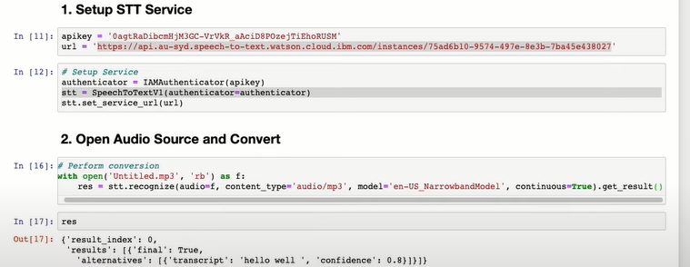
Furthermore, a language change model is also added to the application in order to satisfy users from different regions that speak different languages.
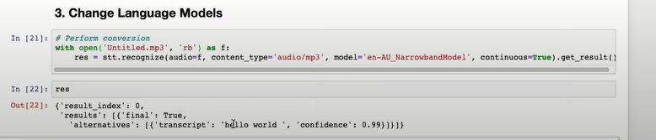

We also built a general user interface for this app, then we modified and tested the VQA model using VQA v2.0 validation set. The overall accuracy is 81.22%.
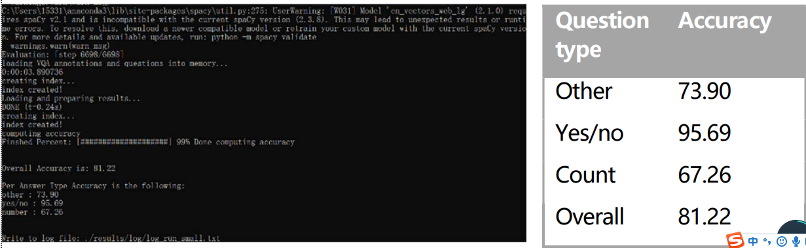
Future work
For future work, we will continuously improve the accuracy of the VQA model. The accuracy is the most necessary part. If the accuracy of the app is not high enough, it may provide wrong information and answers to blind people. Wrong results will lead to accidents, and even threaten the property and health of users. After that, we will combine VQA and speech-to-text API together.

References
- Franky,P(2018)https://towardsdatascience.com/deep-learning-and-visual-question-answering-c8c8093941bc

